COMPONETS 3 ASSIGNMNET
1. Create a component using the concept of overriding , in which you have to extend the features of another component dialog and using it in the current component.
example: Component having its own dialog tab1 and you have to merge the tab2 of the another component by using overriding.
2.Create a components text and title components using the overlay concept in apps .
3.Using the concept of Iparsys create your header and footer component according to ttn site .

tab5
Overriding and Resource Merger
todo-override tab1 of component test2 in tab2 of test3
1.copy and paste an existing resource/component (eg test2)
2.Delete its leaf nodes
3.delete properties of childern of tab2
4.at tab2 put sling:resourceSuperType as path of tab1 of component test2
5.it will inherit all nodes/resources and properties from parent/super
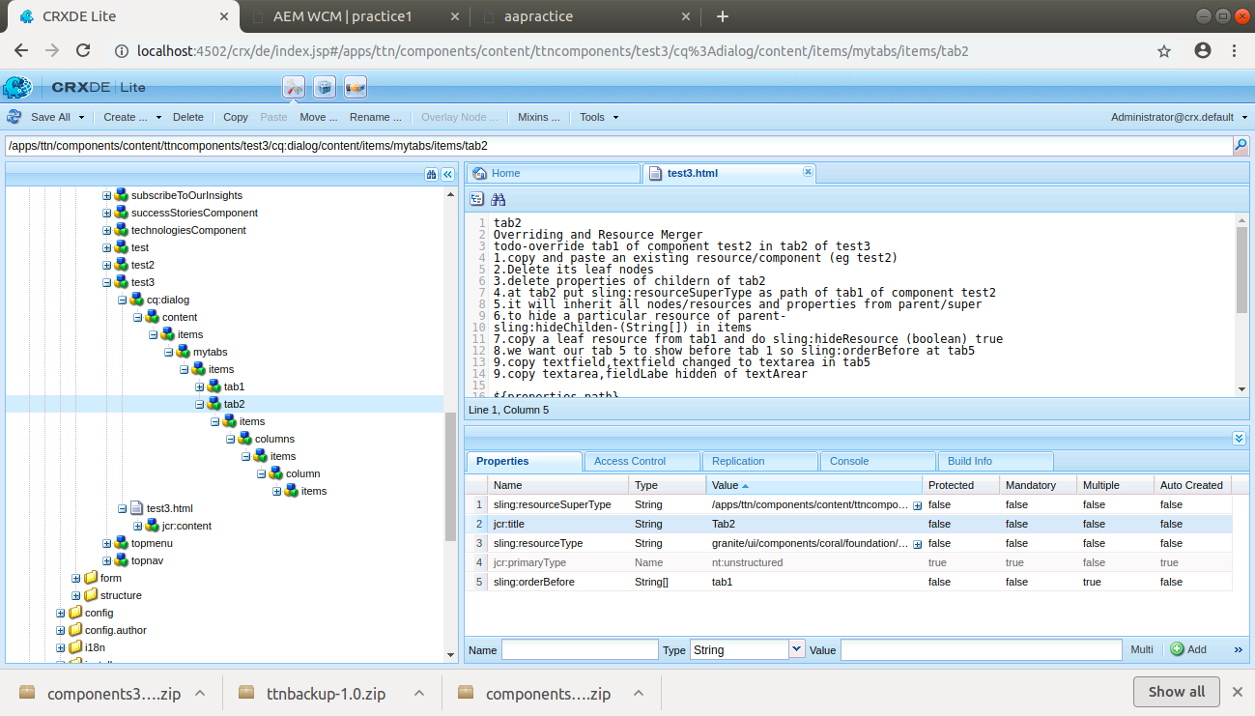

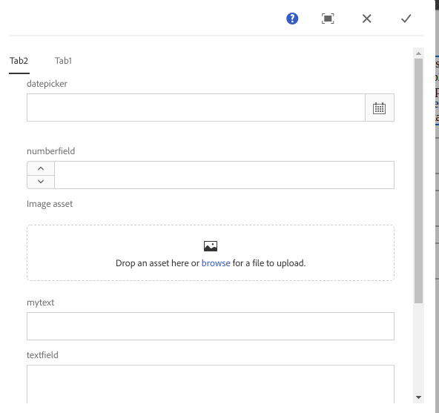

2. to overlay a component
steps
- go to libs and select component which you want to overlay.(eg.libs/foundation/componets-text , title)
- right click and do overlay node
- a similar component structure will be created at apps/foundation/components .
Overlaying is done if we want to provide custom implementation of any components provided in libs.
Anywhere the component is used using relatie path it will first search in apps and find our custom implementation and then search in libs if not found in apps.
